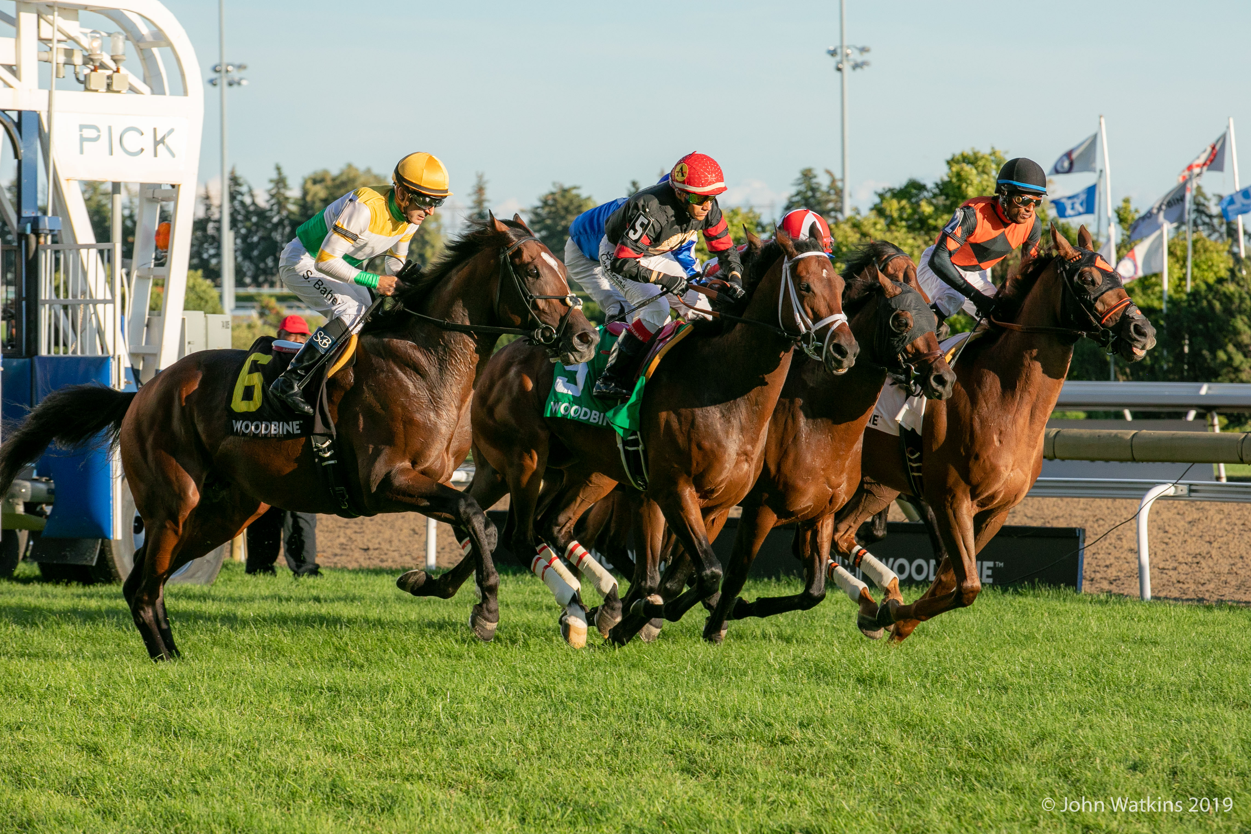

2020 Ontario Thoroughbred Racing Syndicates

There is nothing like the experience of being involved in racehorse ownership. The chance to get up close to your own Thoroughbred in the barn area is only matched by the thrill of seeing him race.

Check out some of the great and affordable ways to join the excitement of owning a racehorse with these syndicate opportunities. This list will be updated as there are more syndicates being developed at the time of writing.

ROSS ARMATA JR.

Trainer Ross Armata Jr. is organizing a syndicate to claim a horse at Woodbine and you can be part of the fun for an all-inclusive price of $5,000.

Ross is seeking up to 20 shares to purchase a top quality racehorse. The syndicate fee covers all bills for one year from the time of the purchase of the horse.

For more information on The Ross Armata, Jr. Syndicate contact Ross Armata Jr. at 416-305-9653 or rossarmatajr@rogers.com or contact the HBPA’s Ownership Specialist, Stacie Roberts ownathoroughbred@gmail.com or 416-230-5190 www.ownathoroughbred.ca

BEAT THE FEET RACING STABLE

Trainer Sylvain Pion claimed 5 year-old gelding King and His Court on July 27, 2019 for the newly formed syndicate Beat the Feet Racing Stable 2019 at Woodbine.

Managed by Sylvain’s wife Terri, this syndicate wrapped up at end of the 2019 meet.

King and His Court was sold to Beat the Feet Racing Stable 2020 and there are now new shares available for 2020. Each share is $2,600 (all inclusive) for the 2020 season at Woodbine.

“As a syndicate member you will get updates on your horses and we have an open door policy at our barn,” said Terri. “There will be dividends at the end of the year with purse money earned or if we decide to sell the horses.”

To find out more information contact Terri Pion at 905-931-0474 or beatthefeetracingstable@gmail.com or contact the HBPA’s Ownership Specialist, Stacie Roberts ownathoroughbred@gmail.com or 416-230-5190 www.ownathoroughbred.ca

CHRYSALID STABLE – KRISTA COLE and NORTHERN DAWN STABLES INC.

Chrysalid Stable, made up of trainer Krista Cole and Sherry McLean of Northern Dawn Stables in Hillsburgh, ON, present to you an opportunity to own a share of lovely chestnut 2-year-old filly aptly named Princess Lannister, a daughter of exciting first year sire Reload from the mare Lovely Cersei, named for the Game of Thrones character.

Princess Lannister is offered at a one time cost of $6,500 for a 5% ownership share in a partnership of 20 shares which will cover all expenses through to the end of the filly’s 3 year old race year in 2021.

Princess Lannister has been Raised to Run and the NEW Chrysalid Stable partnership is offering an opportunity to participate in the fun and excitement of owning a Thoroughbred Racehorse. As an owner you are invited to the backstretch and the barns to get up close and personal with your horse to watch her train and to enjoy and learn from the people that make the racing world go round. On race days you can join together with the trainer and meet the jockey and experience the anticipation, the excitement, and the thrill of cheering on Princess Lannister in her race. Any purse earnings are distributed back to the share owners.

CONTACT: Trainer Krista Cole 647-618-1643 or Manager Sherry McLean 416-576-3815 or email: Chrysalidstable@gmail.com OR contact the HBPA’s Ownership Specialist, Stacie Roberts ownathoroughbred@gmail.com or 416-230-5190 www.ownathoroughbred.ca

CRIMSON FIELDS STABLE

Here is a unique owner experience with claiming horses.

The trainer Andrew Smith at Woodbine will pick out horses to claim and manager David Dare will let you know which horse they are planning to claim and will give you the option to buy a 10% share in the horse (i.e. claim horse for $40,000 – share would be $4000)

There would then be no expenses for as long as the horse continues running and the trainer would be paid 65% of the purse earnings with the remaining 35% of purse earnings distributed back to the share owners.

If the horse gets claimed – then the trainer will be paid 25% of the claim with the remaining 75% distributed back to the owners.

You will have all the perks of ownership including visiting the horse at the barn as well as in the paddock on race days and more.

You can also participate in more than one horse as they will be claiming horses at all different levels.

Contact – David Dare crimsonfields@yahoo.com
or the HBPA’s Ownership Specialist, Stacie Roberts ownathoroughbred@gmail.com or 416-230-5190 www.ownathoroughbred.ca

DALE DESRUISSEAUX

Trainer Dale Desruisseaux and partners are offering shares in two yearlings as they prepare to race in 2020. There are shares available to fit many budgets to allow for those who want to learn and experience the development of a potential racing star.

Contact Dale at 647-530-7879 or doubledracing@hotmail.com or contact the HBPA’s Ownership Specialist, Stacie Roberts ownathoroughbred@gmail.com or 416-230-5190 www.ownathoroughbred.ca

ENCORE RACING CLUB

Want to get in on a 2-year-old for 2020 by one of the country's leading sires?

For 2020 the Encore Racing Club is offering offers shares for a 2-year-old colt by the exciting stallion Souper Speedy and from the mare Dance Chic to Chic, a daughter of Forestry.

The colt was purchased for $15,000 at the 2019 Canadian Premier Yearling Sale at Woodbine and will be trained by Mike DePaulo.

Encore Racing Club – Amanda Roxborough
561-222-9300
encoreracingclub@yahoo.co

OVERHEATH STABLE – LIMITLESS SKY

This racing stable has been operating for over 25 years and the partnership have campaigned some top performers including Questing Knight (earnings $402,091); Pete’s Fancy (earnings $262,259); Ascot’s Legend (earnings $233,551).

The partnership's trainer is Mike De Paulo at Woodbine
Overheath Stable 2019 offers shares in a 2-year-old colt from the first crop of millionaire Dynamic Sky from the stakes winning mare Pink Pallet. He has been named Limitless Sky.

Purchased at the 2019 Canadian Premier Yearling Sale for $30,000, shares in this colt are $7,500 and there are usually 12 shares available. All purse earnings are rolled back into the Stable to cover expenses. The hope is that you won’t have to pay any more than your initial share price for the duration of the horse’s racing career, perhaps four or five years.

Contact contact the HBPA’s Ownership Specialist, Stacie Roberts ownathoroughbred@gmail.com or 416-230-5190 www.ownathoroughbred.ca

THOROUGHBRED RACE CLUB

This is an intimate Thoroughbred racing club, fashioned after The Royal Ascot experience. Appreciate the fun and thrills of horse racing, an elite affair, while learning to navigate through the intricate steps of our exhilarating sport. You and fellow patrons will enjoy a racing interest in up to 10 racehorses and a range of exclusive Club advantages. All this without the expense or long-term commitment of actual horse ownership. Your subscription fee allows you a reasonable cost, low risk glimpse into the life of a Thoroughbred owner.

Contact Vera Simpson at 416-518-1935.

READY TO OWN OR NEED MORE INFORMATION?

If you are ready to start owning a Thoroughbred Racehorse or would like more information contact us and we can help put you in contact with a Trainer, Bloodstock Agent, Syndicate or Club.

Contact Ownership Specialist, Stacie Roberts ownathoroughbred@gmail.com or 416-230-5190 www.ownathoroughbred.ca

